NAME: AMEEN AKEEF BIN MOHD
ARIFF
MATRIC NUMBER: 2022606008
GROUP: JCDCS1104D
MARCH – AUG 2024
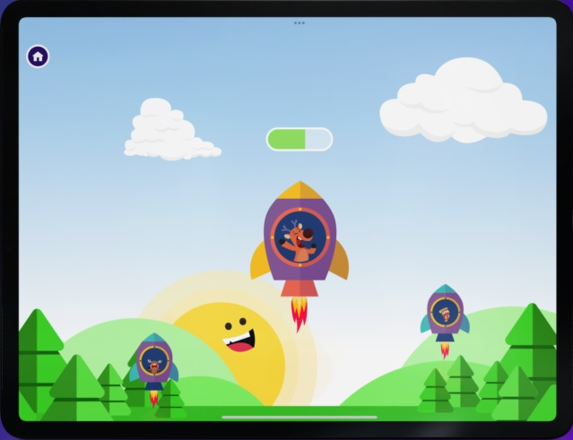
PREPARED BY:
HERE
INSERT MOBILE APP INTERFACE
Mobile Application Development Report
[YOUR MOBILE APP NAME]
Table of Contents

1.0 Project Background 2-4
2.0 Related Mobile App 5
3.0 Features of the App 5-6
4.0 Application Design / Storyboard 7-8
5.0 App User Flow 9
6.0 Project Timeline 10
7.0 Conclusion 11
8.0 References 11

1.0 Project Background

1.1 Introduction
This project, titled "Mario Challenges," aims to create a simplified version of the popular Mario games. Mario games have captivated audiences worldwide with their engaging gameplay, vibrant graphics, and iconic characters. Our project seeks to distill the essence of these beloved games into a more streamlined and accessible format.
"Mario Challenges" will retain the core elements that make Mario games enjoyable, such as platforming, power-ups, and challenging obstacles, while simplifying the graphics and mechanics to suit a broader audience. This approach allows us to introduce new players to the Mario universe and provide a nostalgic experience for long-time fans. By focusing on the fundamental aspects of gameplay and design, we hope to create an entertaining and approachable game that captures the spirit of the original Mario series.

1.2 Problem Statement
The primary motivation behind developing the "Mario Challenges" game is to address the need for accessible and simplified versions of classic Mario games. While the original Mario games are immensely popular, their complexity and advanced graphics can be overwhelming for new players or those with limited access to high-performance gaming devices. Additionally, there is a growing demand for mobile-friendly games that can be enjoyed on-the-go without compromising the core gameplay experience.
Current offerings in the Mario franchise, though rich and detailed, often require significant time investment and advanced gaming skills, which may not appeal to casual gamers. By creating "Mario Challenges," we aim to fill this gap by providing a game that retains the charm and excitement of the original Mario games while being more approachable and easy to play. This project seeks to offer a nostalgic yet fresh experience that can attract a wider audience, including younger players and those looking for a quick and fun gaming session.

1.3 Objectives and Scope of the Project

Objectives
- Develop a Simplified Mario Game: Create a streamlined version of the classic Mario games, focusing on the essential elements of platforming, power-ups, and challenges.
- Enhance Accessibility: Design the game to be easily accessible for players of all ages and skill levels, ensuring a fun and engaging experience without the need for advanced gaming skills.
- Mobile Compatibility: Ensure the game is optimized for mobile devices, allowing players to enjoy "Mario Challenges" on-the-go.
- User-Friendly Interface: Implement a user interface that is intuitive and easy to navigate, enhancing the overall user experience.
- Engaging Gameplay: Maintain the excitement and fun of the original Mario games through carefully designed levels and interactive elements.

Scope
Game Design and Development:
  - Create a series of levels that progressively increase in difficulty, providing a balanced challenge for players.
  - Incorporate classic Mario elements such as coins, power-ups, and enemies, while simplifying the mechanics for a broader audience.
User Interface:
  - Design a clean and intuitive user interface that is easy to navigate.
  - Implement responsive controls suitable for mobile devices.
Testing and Feedback:
  - Conduct thorough testing to ensure the game is free of bugs and performs well on various devices.
  - Gather feedback from users to refine and improve the game before the final release.
Launch and Distribution:
  - Prepare the game for launch on popular mobile platforms such as iOS and Android.
  - Develop a marketing strategy to promote the game and reach a wide audience.

1.4 Impact and Significance of the Web Application to the Targeted Audience
The development of the "Mario Challenges" game holds significant potential to positively impact the targeted audience, which includes both casual gamers and long-time fans of the Mario franchise. The key impacts and significance of the web application are outlined below:

1. Enhanced Accessibility and Inclusion:
By simplifying the gameplay mechanics and optimizing the game for mobile devices, "Mario Challenges" makes the classic Mario experience accessible to a wider audience. This includes younger players, individuals who may find the original games too challenging, and those who prefer gaming on mobile platforms.

2. Nostalgia and Engagement:
For long-time fans of the Mario series, "Mario Challenges" offers a nostalgic experience that retains the charm and excitement of the original games. By incorporating familiar elements such as iconic characters, power-ups, and level designs, the game can re-engage former players and rekindle their love for the franchise.

3. Casual Gaming Experience:
The game's design caters to casual gamers who seek quick and enjoyable gaming sessions. The simplified mechanics and intuitive interface allow players to easily pick up and play the game, making it an ideal choice for short breaks and on-the-go entertainment.

6. Community Building:
The game can foster a sense of community among players by encouraging them to share their experiences, achievements, and tips. This can be further enhanced through social features and online forums where players can connect and interact.

2.0 Related Mobile App
In this report, we will examine two popular mobile applications, Super Mario Run and Dino T-Rex, to understand their features, user interfaces, and interactivity. Both applications offer similar gameplay, but they approach design and user engagement differently. Super Mario Run features a superior interface with enhanced interactivity and impressive 3D animations, providing a more immersive user experience. In contrast, Dino T-Rex adopts a minimalist interface with simpler 2D animations, catering to users who prefer straightforward and easy-to-navigate designs.
The user interface of Super Mario Run is visually rich and engaging, making use of dynamic elements and smooth transitions that captivate users. Dino T-Rex’s minimalist design, while less visually elaborate, ensures quick access to essential features with minimal distractions. When it comes to interactivity, Super Mario Run excels with responsive controls and engaging animations that enhance the overall gameplay experience. Dino T-Rex, though more basic in its approach, offers a clean and efficient user interface that some users may find appealing for its simplicity.
This comparative analysis highlights how Super Mario Run’s advanced interface and animations create a more interactive and visually appealing experience, whereas Dino T-Rex’s minimalist design focuses on simplicity and ease of use, providing valuable insights for the development of new mobile applications.

3.0 Features of the App
While the features of "Mario Challenges" are still being finalized, the game will typically include the following elements to enhance the user experience:
- Challenging Levels: A series of progressively difficult levels that test the player's platforming skills.
- Power-Ups and Collectibles: Classic Mario elements such as coins, mushrooms, and other power-ups that enhance gameplay.
- 2D Animations: Engaging 2D animations that bring the nostalgic experience for the user especially for the fandom.
- Intuitive Controls: User-friendly controls optimized for mobile devices to ensure smooth and responsive gameplay.
- Leaderboards: A system to track high scores and achievements, encouraging competition among players.
- Character Selection: Options for players to choose and customize their favorite Mario characters.
- In-Game Tutorials: Helpful tutorials and tips to guide new players through the basics of the game.
- Regular Updates: Continuous updates with new levels, challenges, and features to keep the game fresh and engaging.
These features aim to provide a comprehensive and enjoyable gaming experience, ensuring that "Mario Challenges" appeals to both new and seasoned players.

4.0 Application Design / Storyboard
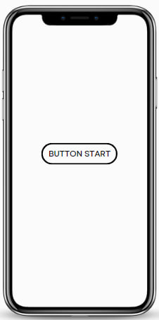
FIRST PAGE : THE INTERFACE WILL HAVE THE BACKGROUND AND THE BUTTON TO START THE GAME
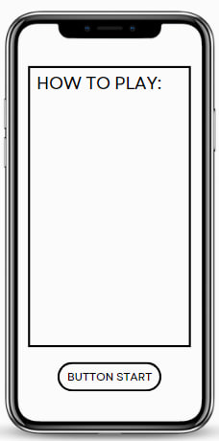
SECOND PAGE : WILL DISPLAY THE INSTRUCTION AND HOW TO PLAY THE GAMES ,AND AT THE BUTTOM HAVE A BUTTON TO ENTER AND START THE GAMES.
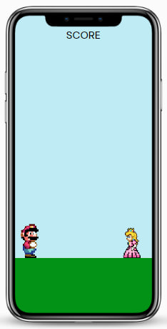
THIRD PAGE : WILL DISPLAY THE IN-GAME WHICH IS HAVE THE MARIO THAT HAVE TO DODGE THE PRINCESS BY JUMP.
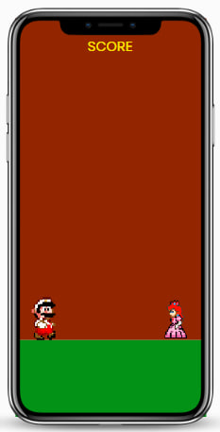
FOURTH PAGE : THE OVERALL INTERFACES AND SITUATION OF THE GAMES WILL BE CHANGE DEPENDS ON THE SCORE. MORE HIGHER THE SCORES, THE SPEED OF THE PLATFORM WILL INCREASING AND IF IT ABOVE THE 50 THE BACKGROUND WILL TURN TO DARK RED.
Sample of storyboard design

5.0 App User Flow

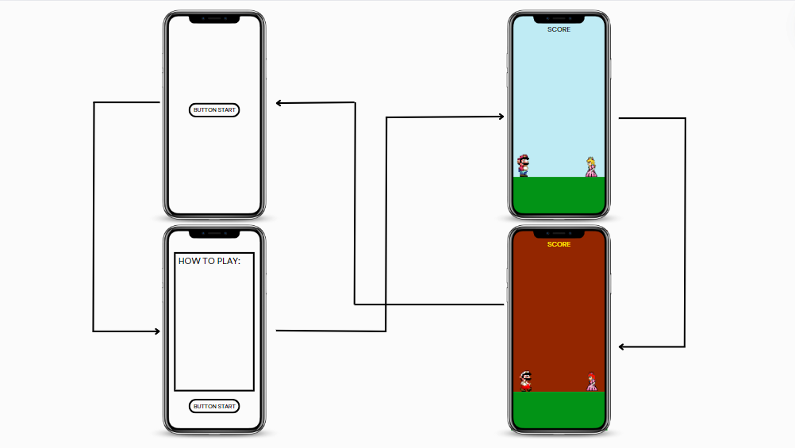

6.0 Project Timeline
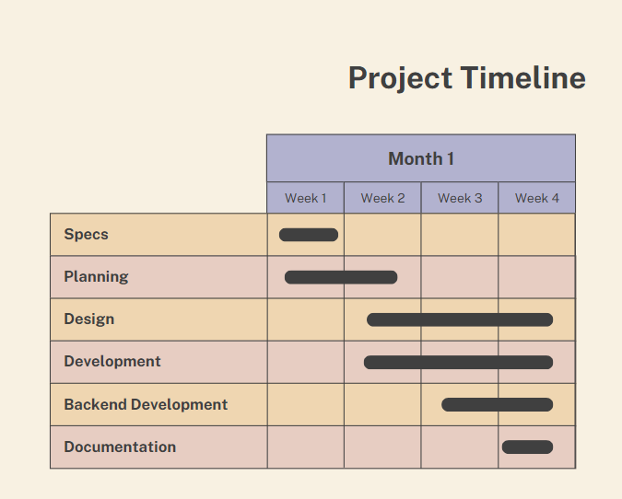

7.0 Conclusion

Advantages of the Mobile App
- Easy to Access: Simplified gameplay and mobile-friendly design make it suitable for all players, including beginners.
- Nostalgic Appeal: Keeps the charm of classic Mario games, attracting old fans.
- Fun Gameplay: Features challenging levels, power-ups, and 3D animations for an enjoyable experience.
- User-Friendly: Simple controls and a clear interface make it easy to use.
- Social Features: Leaderboards and sharing options create a sense of community.

Project Outcomes
- High-Quality Game: A well-designed game that captures the fun of the original Mario series.
- Wide Audience Reach: Appeals to various demographics, from casual gamers to Mario enthusiasts.
- Regular Updates: New content and improvements keep the game fresh and engaging.
- Positive Feedback: User feedback helps refine the game to meet player expectations.

Commercialization
The app's broad appeal and engaging features make it attractive for commercialization. It can generate revenue through in-app purchases, ads, and premium content. The nostalgic elements and fun gameplay encourage user retention and word-of-mouth promotion, leading to long-term success and profitability.

8.0 References
Mobile App Games :
- Super Mario Run Games
- Dino T-Rex Games
Website :
- MIT App Inventors 2
- YouTube : https://www.youtube.com/watch?v=gxPWJTsluTs&t=284s

Rubrics Mobile App Report (5%)
Student Name: | AMEEN AKEEF BIN MOHD ARIFF
Matric Number: | 2022606008
Project Title: | SUPER MARIO CHALLENGE

No | Tasks | 0 | 1 | 2 | Weight | Scores earned (0-2) | Total earned
1 | Entrepreneurial Mind & Opportunity | No entrepreneurial idea for value adding/solving user/customer needs. | Business idea is clear but does not fulfill the realistic user/customer needs. | Able to mobilize the idea to become opportunity according to the business strategy and fulfill the user/customer needs. | 3
2 | Project background | Not able to write ideas systematically and with limited clarity and accuracy | Able to write ideas systematically AND fairly clearly and accuracy | Able to write ideas systematically AND with excellent clarity and accuracy | 5
3 | Mobile app features | Not achievable or below expectation. | Achievable but level of complexity is below expectation. | Achievable and acceptable level of complexity. | 5
4 | Functional Design  -app flow | Not achievable or below expectation. | Achievable but level of complexity is below expectation. | Achievable and acceptable level of complexity. | 4
5 | Interface Design  - application design | Not achievable or below expectation. | Achievable but level of complexity is below expectation. | Achievable and acceptable level of complexity. | 4
6 | Language used  - There are no spelling, grammar, or punctuation errors. | Not achievable or below expectation. | Achievable but level of complexity is below expectation. | Achievable and acceptable level of complexity. | 2
7 | Formatting  - The organization of proposal is in correct order and neat. | Not achievable or below expectation. | Achievable but level of complexity is below expectation. | Achievable and acceptable level of complexity. | 2
 | TOTAL POINTS |  |  |  |  | 10
TOTAL
5%

Mobile Application Project Rubric (25%)

Student Name:
Matric Number:
Project Title:

No | User Interface & Information |  | 0 | 1 | 2 | Weight | Scored Earned (1-2) | Total earned
1 | Intuitive and user-friendly design / Layout design |  | not exist | Incorrect/ incomplete | Complete | 5
2 | Responsive design for various screen sizes |  | not exist | Incorrect/ incomplete | Complete | 5
3 | Contains the home page, information about us, or pages to view related information |  | not exist | Incorrect/ incomplete | Complete | 5
4 | Effective use of navigation |  | not exist | Incorrect/ incomplete | Complete | 5
 | Functionality
5 | Include calculation process (The calculation used is correct and relevant) |  | not exist | Incorrect/ incomplete | Complete | 5
6 | Mobile app content / features (The content is related to the topic and complete) |  | not exist | Incorrect/ incomplete | Complete | 5
7 | Completeness of Application |  | not exist | Incorrect/ incomplete | Complete | 5
8 | Database Management (Use at least TinyDB to store data and it store the data completely) |  | not exist | Incorrect/ incomplete | Complete | 5
9 | Critical Thinking & Problem Solving |  | not exist | Incorrect/ incomplete | Complete | 5
10 | Creativity on the mobile app (Excellent, proper app design) |  | not exist | Incorrect/ incomplete | Complete | 5
TOTAL POINT WEB APPLICATION |  |  |  |  |  |  | 100
 |  |  |  |  |  |  | TOTAL 25%
Individual Presentation Rubric (5%)
Student Name:
Matric Number:
Project Title:

 |  | 1 | 2 | 3 | 4 | 5 | SCORES EARNED (1-5)
No | Assessment values | Weak | Fair | Good | Very Good | Excellent | SCORES EARNED (1-5)
1 | Delivery of ideas (Communicative ability) | Not able to deliver ideas clearly and require major improvements | Able to deliver ideas and require further improvements | Able to deliver ideas fairly clearly and require minor improvements | Able to deliver ideas clearly | Able to deliver ideas with great clarity
2 | Confident and articulate delivery of ideas (Communicative ability) | Not able to deliver idea confidently and articulate | Able to deliver ideas with limited confidence and effect and require further improvements | Able to deliver ideas fairly confidently and effectively and require minor improvements | Able to deliver ideas confidently effectively and articulately | Able to deliver ideas with great confidence, effect and articulately
3 | Understand and respond to questions (Communicative ability) | Not able to understand and respond to a question | Able to understand and answer questions but not able to accurately answer the question | Able to understand and answer questions satisfactorily | Able to respond to questions well | Able to fully understand and respond to questions very well
4 | Clarity, accuracy and systematically written academic discourse (Slide content) | Not able to write ideas systematically and with limited clarity and accuracy | Able to write ideas systematically BUT with limited clarity and accuracy | Able to write ideas systematically AND fairly clearly and accuracy | Able to write ideas systematically, clearly and accuracy | Able to write ideas systematically AND with excellent clarity and accuracy
 |  |  |  |  |  | TOTAL MARKS
 |  |  |  |  |  | TOTAL 5%

