
PRO-OFFICE TECHNOLOGY SDN. BHD.
USER ACCEPTANCE TESTING(UAT)
PROJECT : ATTENDPRO
(CHECKIN MODULE)
NAME | AMEEN AKEEF BIN MOHD ARIFF
POSITION | INDUSTRIAL TRAINING
INDUSTRIAL SUPERVISOR | EN. KHAIRUL ZHAFRI

Instructions for System Testers
The purpose of this document is to test the functionality within the new AttendPRO system. This test form is designed to evaluate the features and functions included in the project. The project testing is intended for two user levels:
- User
- Admin
The purpose of this test is to ensure that all systems and features are working correctly.

Objectives of AttendPRO System Testing:
Verify System Accuracy and Functionality:
-Ensure that all features of the AttendPRO system work as intended for both users and administrators, including login, check-in/check-out, and data management.
Identify Bugs and Issues:
-Detect and document any bugs, malfunctions, or performance issues in the system, ensuring they are reported for resolution before deployment.
Evaluate User Interaction:
-Assess the usability and user experience for both regular users and administrators, ensuring that the system is intuitive and easy to navigate.

Scope of Testing:
The scope of the testing process will include but is not limited to:

Login and Authentication:
- Verifying that both users and admins can securely log in and out of the system using their credentials.
- Ensuring proper session handling, preventing unauthorized access to sensitive data.

User Dashboard:
- Check-in Functionality: Testing that users can successfully check in using the system, including ensuring that the check-in timestamp is accurately recorded in the database.
- Current Location Trace Function: Testing the accuracy and reliability of the location tracking feature, ensuring that the user’s current location is properly logged during check-in. The map or location data should reflect the user’s actual geographical position.
- Attendance Records: Ensuring that users can view their attendance records without errors, with accurate display of check-in, check-out times, and reasons for absence.
- Leave Application: Verifying that users can apply for leave, including filling out leave details and ensuring the application is sent to the admin for approval.

Admin Dashboard:
- View Today’s Check-in Data: Testing the admin’s ability to view all staff check-ins for the current day, ensuring the data is correctly grouped and displayed, showing check-in times and employee details.
- Export Data to Excel: Ensuring the admin can export today’s check-in data into an Excel file, with all fields properly formatted and organized in the report.
- Data Filtering by Name and Date: Testing the filtering functionality that allows the admin to filter check-in data by employee name and date range. This ensures admins can easily find specific records and export filtered data if needed.

No | Steps and Explanation | Visualize |  | Acceptance (Yes/No)
1 | USER PART  - Firstly, user will have to login in the form with their ‘username’ and ‘password’ given.  - After user fill in the form, user can click the Login button and direct go to the main page which is the checkin page.  *Username = ‘akeef’  *Password = ‘1234’ | 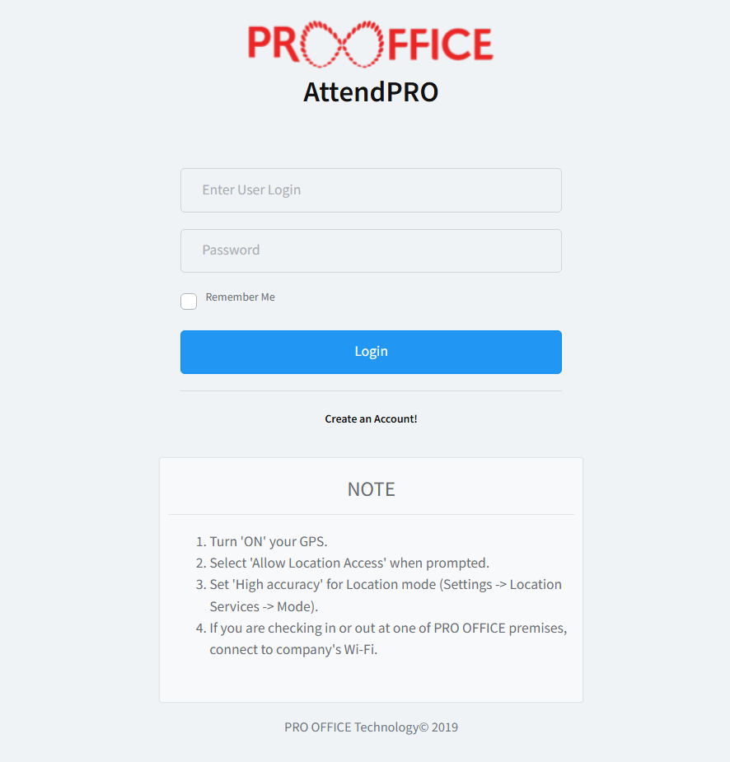 | 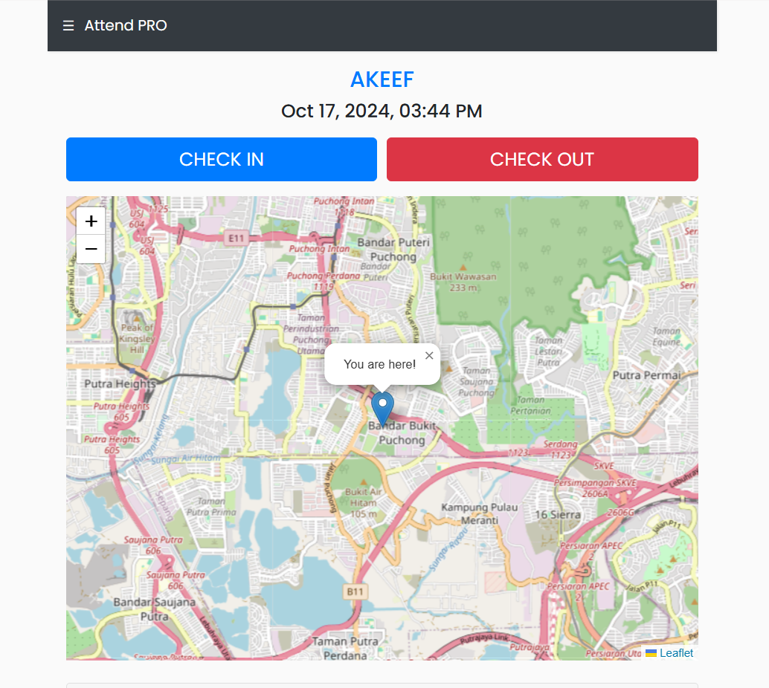
2 | - User see the map display which is that is the user’s current location to trace user’s location while do the checkin or checkout.  - In that page user will have two option which is checkin and checkout.  - After user click one of that, it will open the option of the reason of the checkin like where you going or where you at. |  | 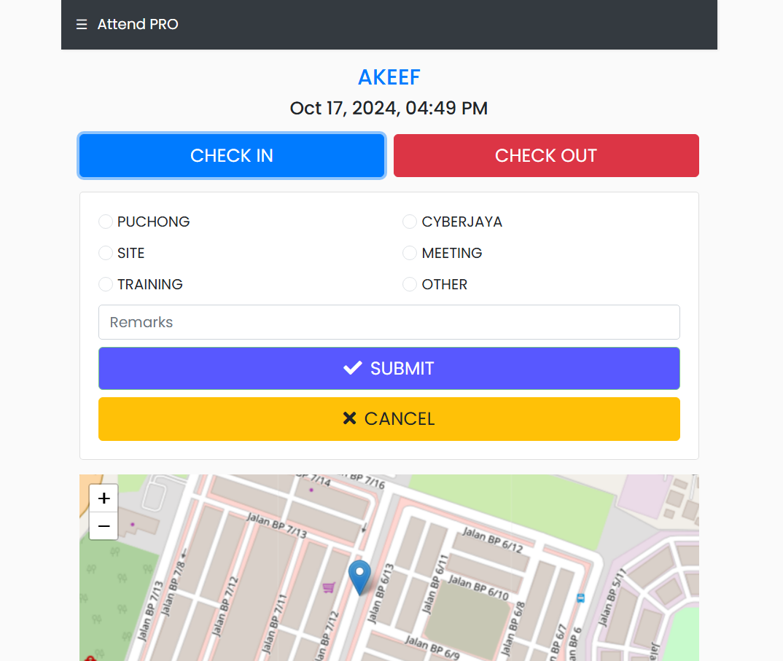
3 | - After that, user will click the submit button after finish the checkin or checkout.  - After the process finished, it will display message either your checkin process is succeed or not. | 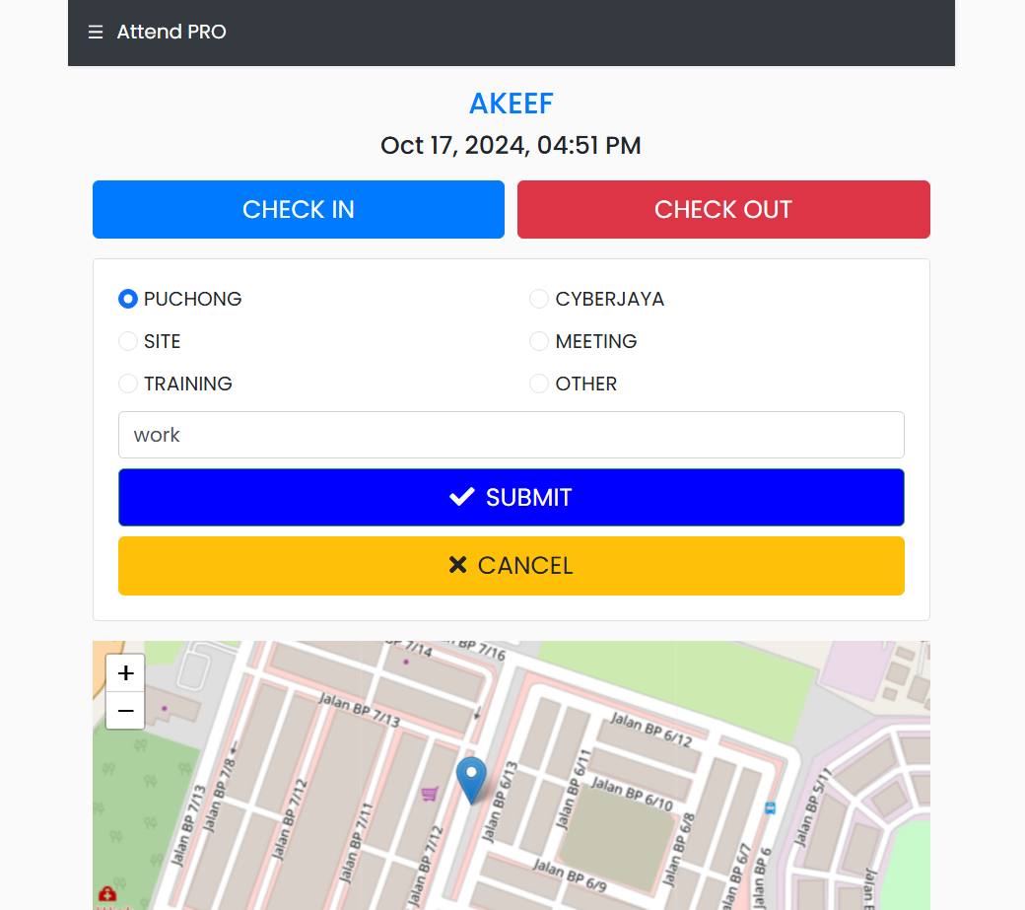 | 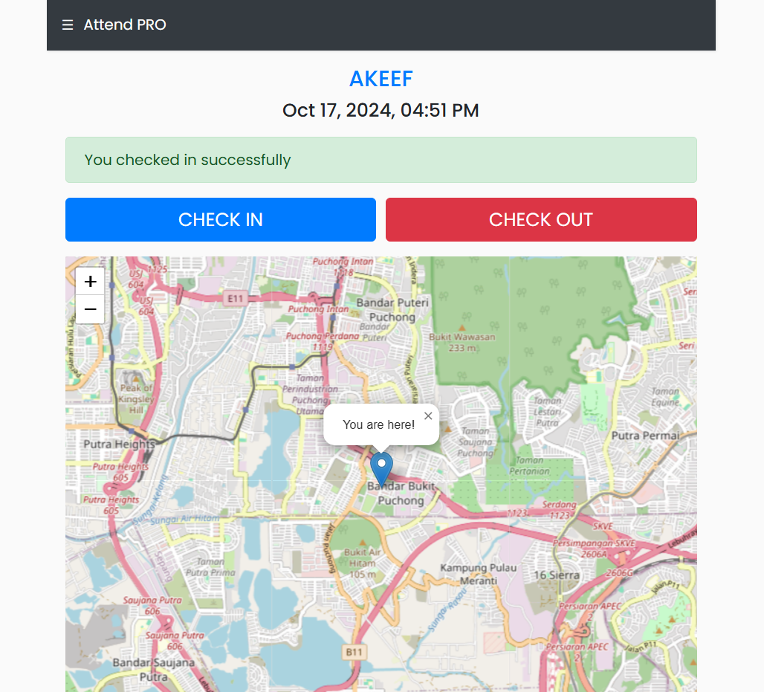
4 | - After finish the checkin session, user can view their history of their checkin or checkout at the real time at the bottom of the page. | 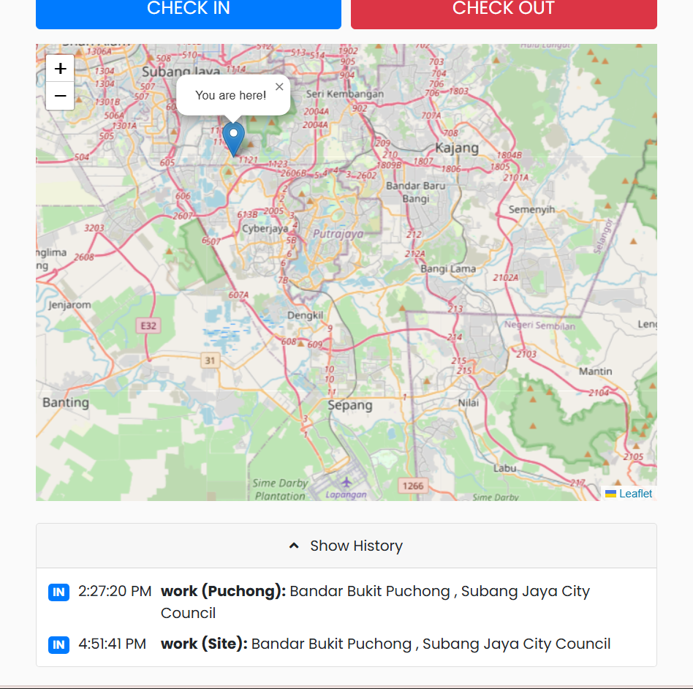
5 | ADMIN PART  - The management or admin department can monitor your activity of checkin or checkout in their admin page. All the staff’s data of checkin will be display in this.  - Admin can know staff’s time of checkin, staff’s location, and their from what department. | 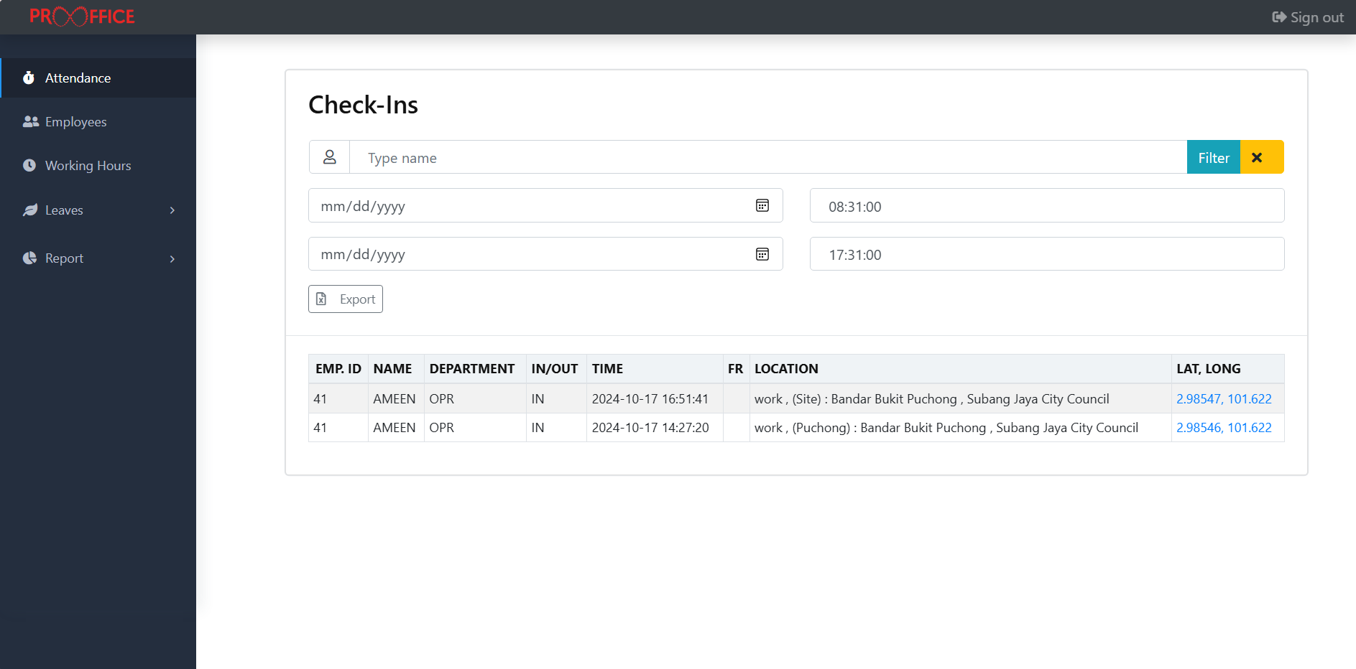
6 | - In the page will display data of the day. It will refresh the data every single day.
7 | - Admin can export the data display by click the ‘export’ button to export it into the excel form.
8 | - After click the button, it will download the excel file which is the file of the user’s data. | 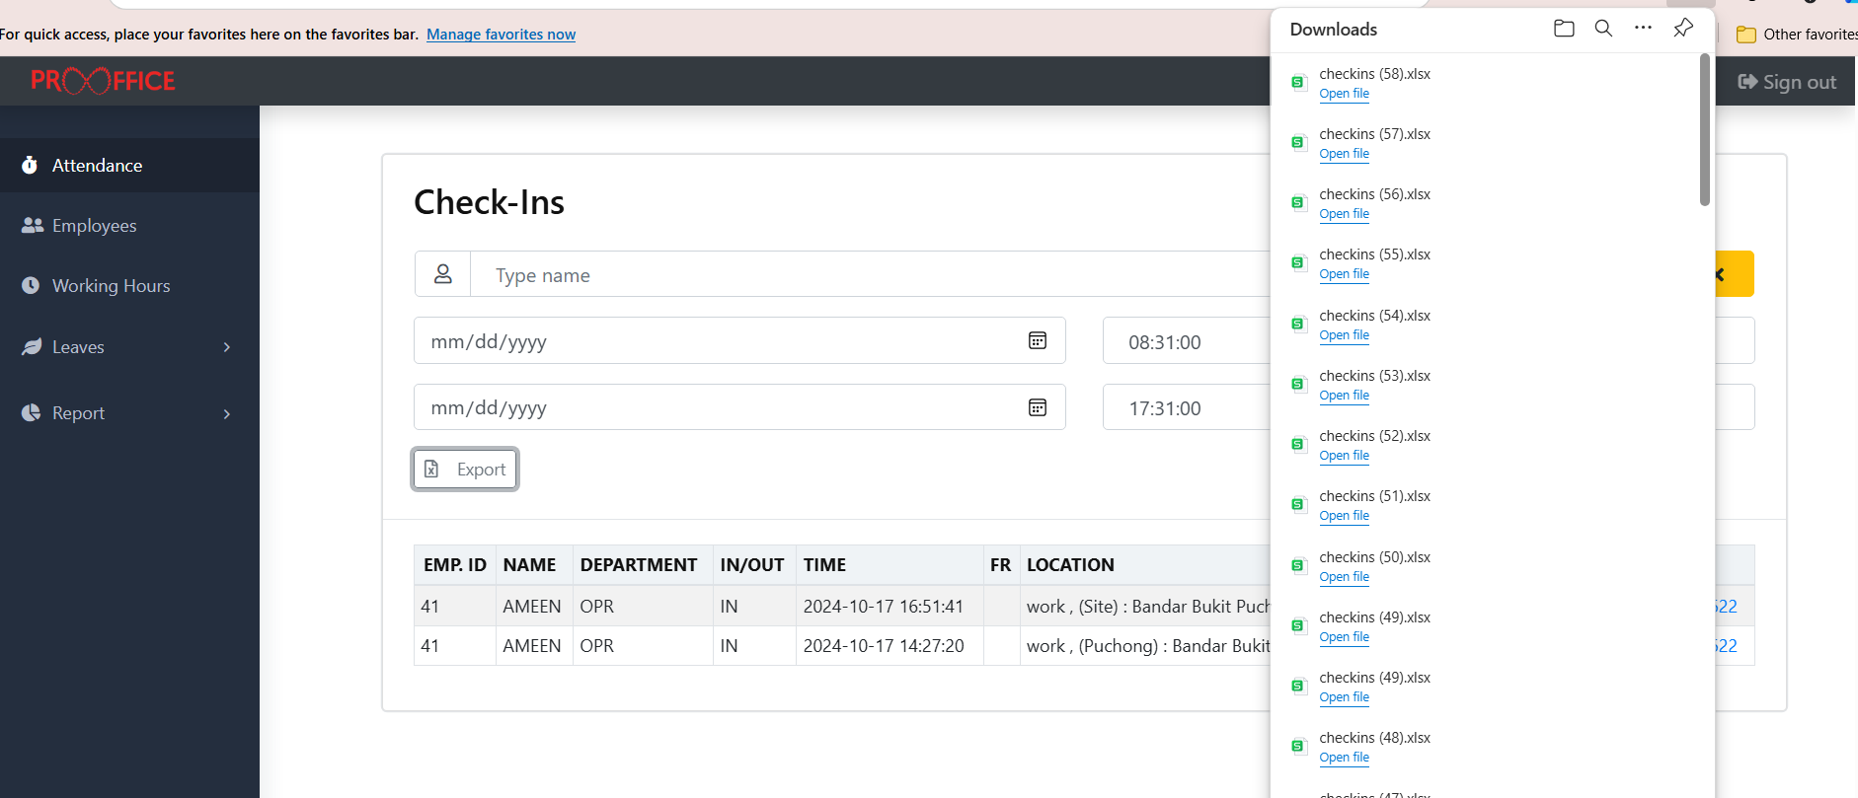
9 | - In the excel it will display all user’s checkin data included the user’s information. | 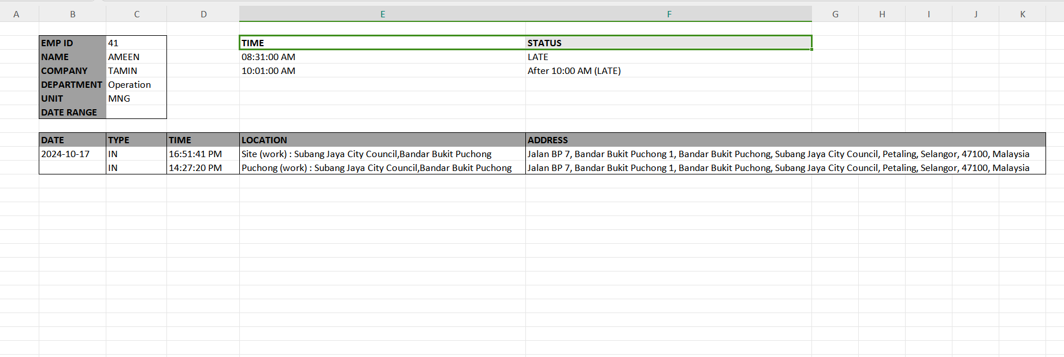
10 | - Admin can filter the display to make it narrow in searching for the specific users or specific date of checkin.  - Admin can filter by write the name they want in the form, choose the specific date and click the ‘filter’ button. | 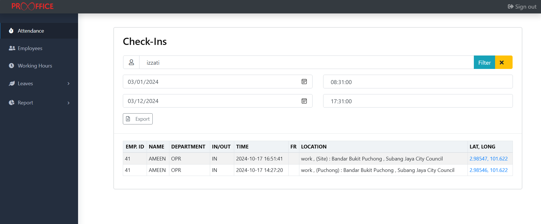
11 | - After it display the specific data based on the filtered data by the admin, you can click the ‘export’ button to export it into the excel file. | 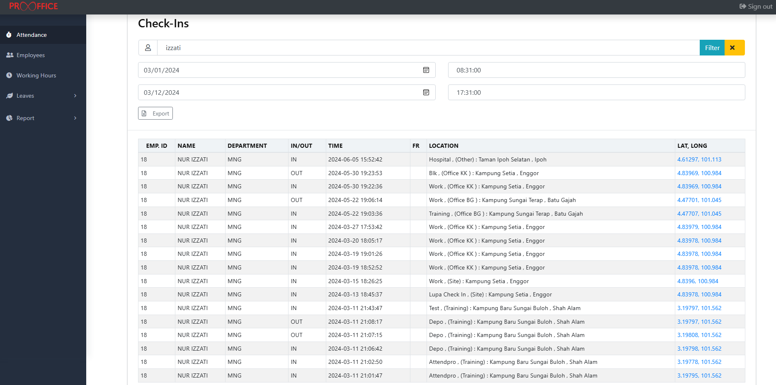
12 | - Excel will display the data filtered. | 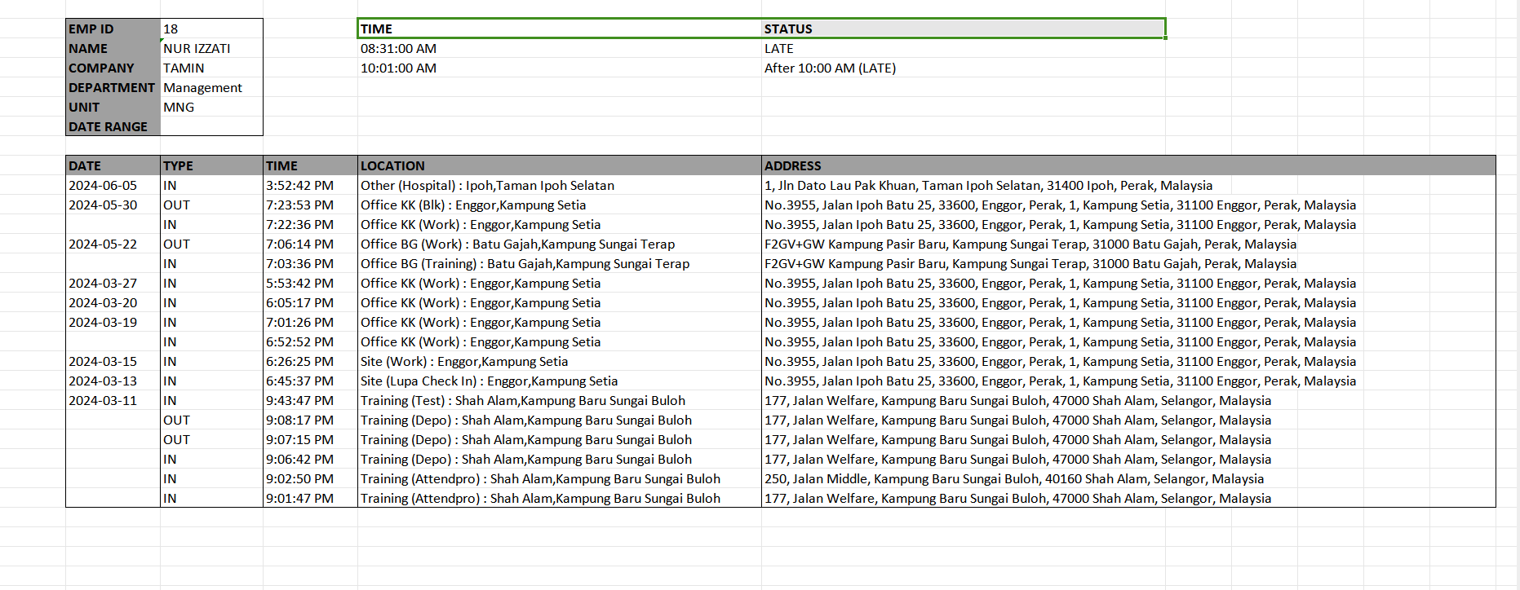
13 | - If admin want just for the specific date with multi user in it, just filter the date and blank the name form.  - After that click the ‘export’ button again to export it. | 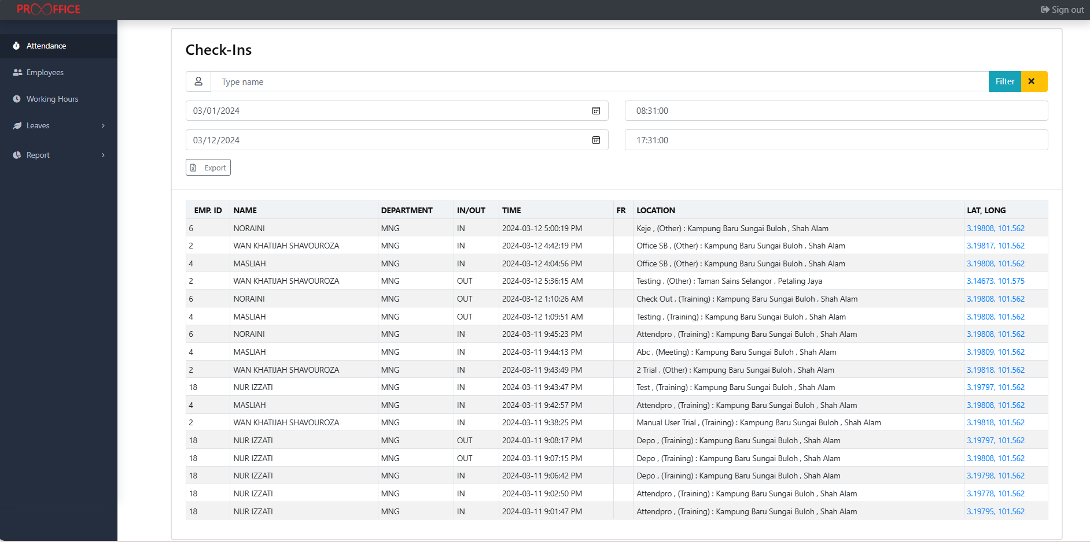
14 | - The excel file will separate it into many sheets depends the data on that filtered date. It will be named by the user’s name. | 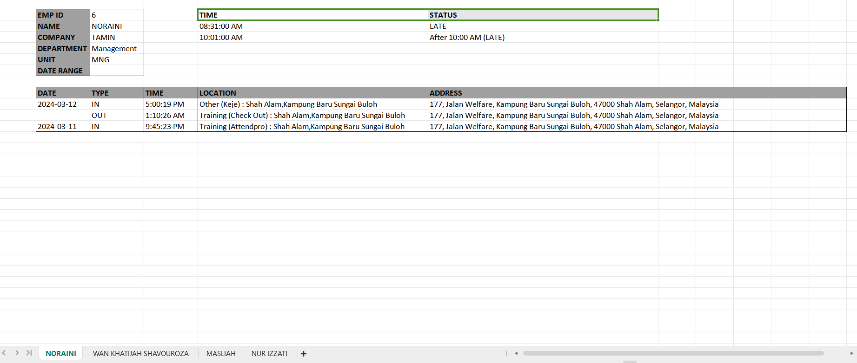

User Acknowledgment
By signing this document, the user confirms that they have read, tested, and accepted the functionalities of the system described above.

Tested & Accepted By:

Name:
Position:
Date:
Confirmed By:

Name:
Position:
Date:

