LAB TEST (50 Marks) : ITT320 Introduction to Computer Security
Group : JCDCS1104D_____ Note: You can screenshot some of the result and submit along with this question.
Name : AMEEN AKEEF BIN MOHD ARIFF________ ID: 2022606008_______________
Answer the following questions by examining the following captured information using the command prompt in Windows utilities

QUESTION 1 (Windows Client Configuration / Information Gathering)
- Open the Windows Command Prompt and view the network card configuration using the correct Command to get the below answers. Draw the output list by screenshotting the result and answer the below questions.
(10 Marks)
- What is your IP address?
- What is your subnet number?
- What is your default gateway?
- What is the physical address of your computer?
- What is your domain name system address?

- IP address : 192.168.0.119
- Subnet number : 255.255.255.0
- Default gateway : 192.168.0.1
- Physical address : 7C-B0-C2-49-1C-13
- Domain name : http://testphp.vulnweb.com/
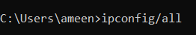
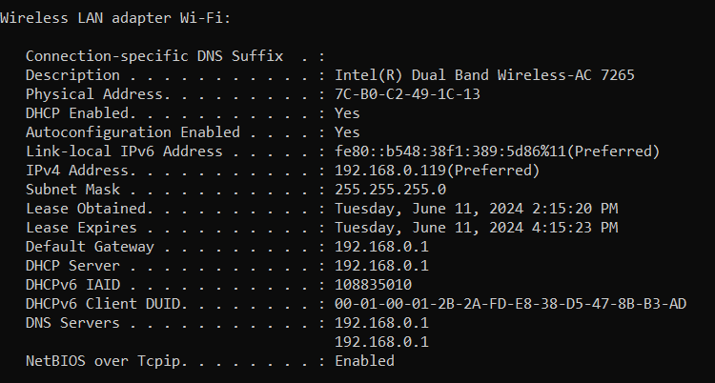

- Change the IP address of your Windows OS to 192.168.YY.XX. Maintain the existing subnet number in YY and change the XX to any other IP. Observe the new change using the correct Command, and screenshot the reflected IP address.
(2 Marks)
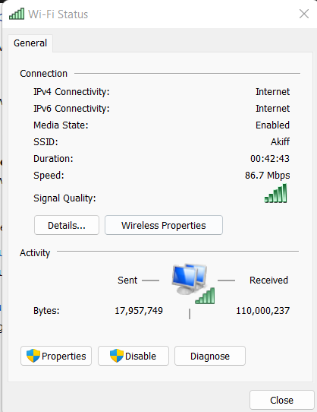

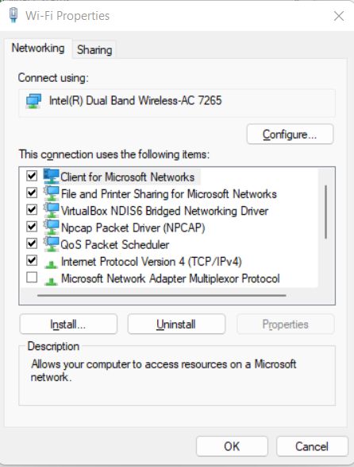

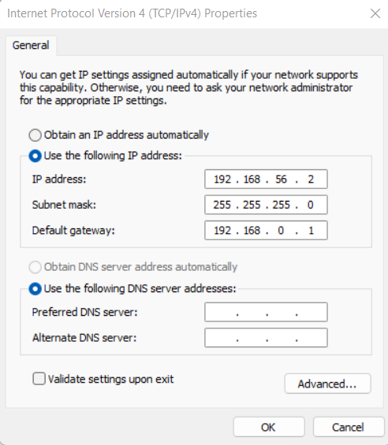

QUESTION 2 (NMAP IP Scanning in Windows)
Please ensure you have the latest version of Nmap installed on your PC. Connect your PC to UiTM WiFi. Open your PC’s command line and do the following assessment. Please do not scan any website outside the UiTM Network.
- You are finding the number of connected systems in your Network and other network info by answering the following questions.
- What is the Nmap command to find the total number of connected systems in our Network?
(2 Marks)
- How many hosts do you find in your Network by using the above 2(a) commands?
(2 Marks)
- How long did the scan take?
(2 Marks)
- Nmap -sn “192.168.0.119”
- 1 host up
- 0.12 seconds
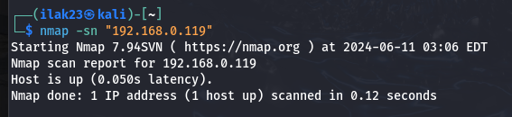

- TCP / UDP Open Ports scanning (For your PC only)
- What is the Nmap command to look at the TCP and UDP connections?
(2 Marks)
- What are the TCP Ports open from the scanning?
(2 Marks)
- What are the UDP Ports open from the scanning?
(2 Marks)
Attach the screenshot of your result.

- nmap -sV -p 1-1000 “192.168.0.119”
ii. TCP:
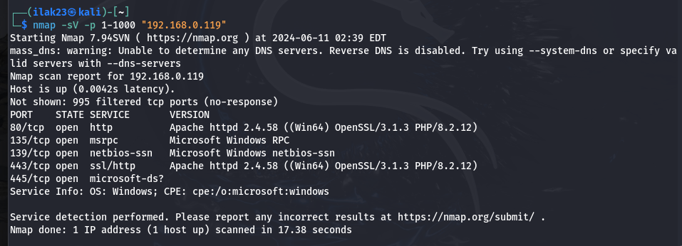

- NMAP Stealth Scan (For your PC only)
- What is the Nmap command to scan in depts to find the services and open ports?
(2 Marks)
- How many ports did it find?
(2 Marks)
Attach the screenshot of your result.
- Nmap -sV -p 1-1000 “ip address”
- 5 open ports

- OS Fingerprint (For your own PC only)
- What is the Nmap command to find the operating system types used by the target system?
(2 Marks)
- What was the guess made by Nmap? Was it correct?
(2 Marks)

- Nmap -O “192.168.0.119”

Attach the screenshot of your result.

QUESTION 3 (Gaining Access / Exploitation of Web Application)

A web application runs on one of the PC in this lab environment. The web application system, MiHerbs, holds information on Malaysian Indigenous Herbs. It consists of a web administrator view and front end user view. The administrator can log in as an administrator to manage the website, such as inserting new user roles, adding new herbs data, updating and deleting herbs data, and performing other web admin tasks. The end user can search the information regarding the herbs using the search facility. However, the web application has not yet been assessed for its threats assessment, security, and vulnerabilities level. As a penetration tester, you are required to perform a Vulnerability Assessment and Penetration Testing (VAPT) on the web application.

Based on your VAPT activity, answer the following questions.
- Perform a Vulnerability assessment of the web application by using Vega Web Scanner and list all vulnerabilities available on the web applications based on the severity level.
(6 Marks)
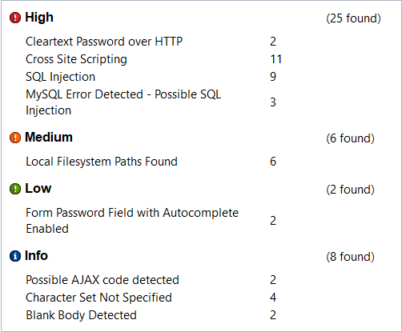

- Based on the web application vulnerability in (a), conduct a database exploitation on the miherbs to gain sensitive information.
  - What is database name do you find that related to miherbs?
  - How many tables are available in the miherbs database?
  - What is the table name that relates to user details?
(6 Marks)
- Database : acuart and information_schema
- 8 tables
- Tables name:
-Artist
-carts
-Categ
-featured
-guestbook
-pictures
-products
-users

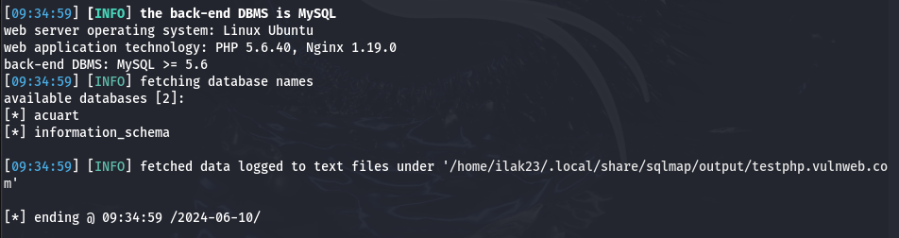
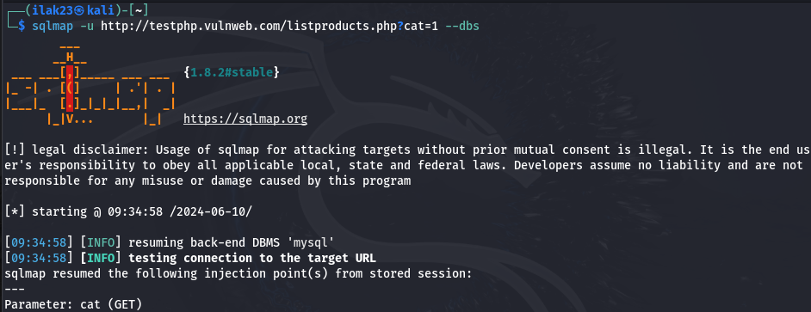
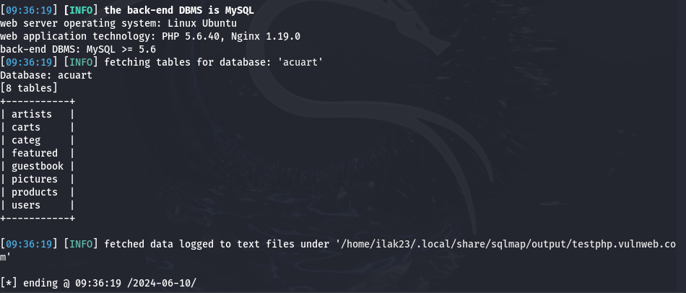

- List all usernames and passwords of the administrator for the miherbs application.
(6 Marks)
Username : test
Password : test

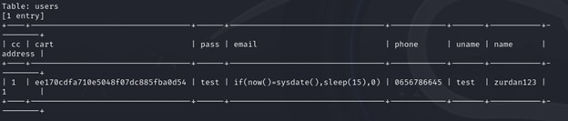

END OF QUESTION

